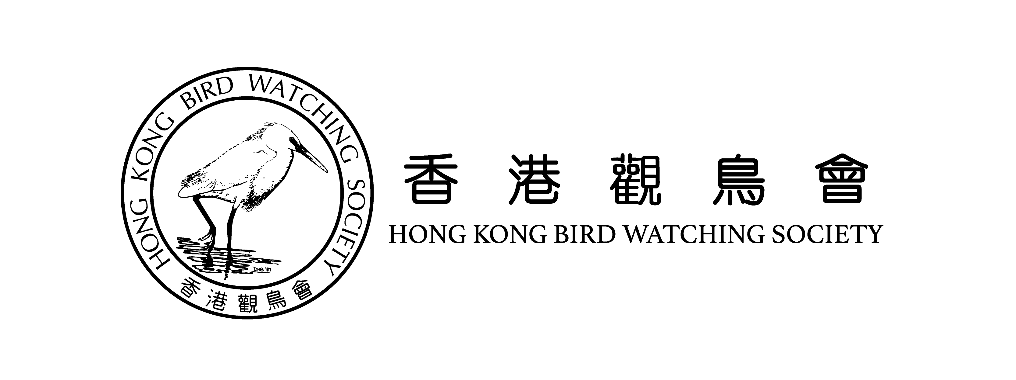
The Hong Kong Bird Watching Society
香港觀鳥會
Donation Form 捐款表格

w: www.hkbws.org.hk
e: donate@hkbws.org.hk

t: 2377 4387 f: 2314 3687
---------------------------------------------------------
Yes! I would like to help protecting birds
我願意為雀鳥保育出一分力！
by making one-off donation of 一次性捐款:

$300 $500 $1000 Other amount 其他金額: ________

Donation Methods 捐款方法
Crossed Cheque 劃線支票
Cheque No. 支票號碼 __________________________________
Issuing Bank 發出銀行 __________________________________
Payable to 抬頭：“The Hong Kong Bird Watching Society” 「香港觀鳥會」

Direct Transfer 直接存款
Bank of China Account No. 中國銀行戶口：012-878-1076439-9
Please send Cheque/ Direct Transfer receipt together with this form to:
The Hong Kong Bird Watching Society,
7C, V Ga Building, 532 Castle Peak Road, Lai Chi Kok, Kowloon, Hong Kong
請把支票或直接存款收據連同此表格寄到：九龍荔枝角青山道532號偉基大廈7樓C室 香港觀鳥會
*Tax deductible receipts will be issued with donation of HK$100 or above. 捐款$100或以上可憑收據申請扣稅
Personal Particulars 個人資料
Name (Dr. / Mr. / Ms. / Miss) : ___________________________________________________________________
姓名 (博士/ 先生 / 女士 / 小姐) : ___________________________________________________________________
Name on receipt捐款收據抬頭: ___________________________________________________________________
Contact No. 聯絡電話： ____________________________ Email 電郵： ________________________________
Language 通訊語言： ◻English ◻中文
Address 地址 _____________________________________________________________________________
Signature簽署: ______________________________________________________________________________
The Hong Kong Bird Watching Society (HKBWS) processes your personal data strictly in accordance with the Data Protection Act; and your data will be used by HKBWS and their service providers only for communications between you and HKBWS.
If you do not like to receive any promotional materials from HKBWS, please tick the box 口
香港觀鳥會嚴格遵守個人資料條例處理所收到的個人資料，並只會用於香港觀鳥會及受其委託的服務提供者與你聯絡。若你不願意收到本會的宣傳資料及通訊，請在方格內加上剔號。◻

感謝您的支持讓我們保護更多雀鳥。
Thank you for your support so that we can protect more birds!

